Abstract

Winds of death is a top-down shooter style game, available on our website.   
The core audience for this game would be young adults and teenagers

Winds Of Death  
Game Design Document

Aleksandar Marinov (B00351200), Mohammed Latif (B00333837), Fraser McAulay (B00371477), Mihai Maftei (B00359190)

Contents

Game Design 2

Game Overview 2

Game Concept 2

Characters 3

Plot 4

Gameplay 4

Game Interface Design 4

Game Environment/Level Design 5

Game Implementation 7

Game Features and Future Development Plans 7

Gameplay & Player Mechanics 7

Pseudocode 8

Project Management 10

Gannt chart as of 15th September 2021 - Start of project 11

Gannt chart as of 23rd October 2021 - Halfway point of project 11

Gannt chart as of 11th December 2021 – Finishing point of project 12

UML Diagram 12

Roles and responsibilities 13

Fraser McAulay B00371477 13

Mohammed Latif B00333837 13

Mihai Maftei B00359190 13

Aleksandar Marinov B00351200 14

Software Development Lifecycle Methodologies 14

GitHub Link 14

Version 1 14

References 15

# Game Design

## Game Overview

Winds of death is a top-down shooter style game, available on our website. The core audience for this game would be young adults and teenagers. We chose this audience as they are the ones most seen to play shooter games. To make this game, we will be using WebStorm from JetBrains and Phaser Editor 1.5.4 as a development environment. The game will be made with the framework Phaser version 3.55.2 "Ichika", and the main programming language will be JavaScript. The goal of the game is to kill as many zombies as possible while progressing through a series of linear levels. There will be opportunities to use different guns throughout the levels to aid player progress.

## Game Concept

We chose to design Winds of death as a 2D co-op top-down zombie shooter, a subgenre that we think is extremely attractive for our desired audience. This idea came from one of our developers. He mentioned the style of game and we started talking about it and looking up past browser games with a similar style. The games we got ideas from where: Boxhead: The Zombie Wars, Zombies Ate My Pizza, Dead Estate and Mecha Team Maverick.  
  
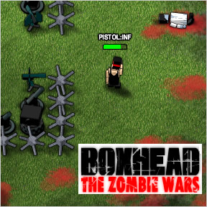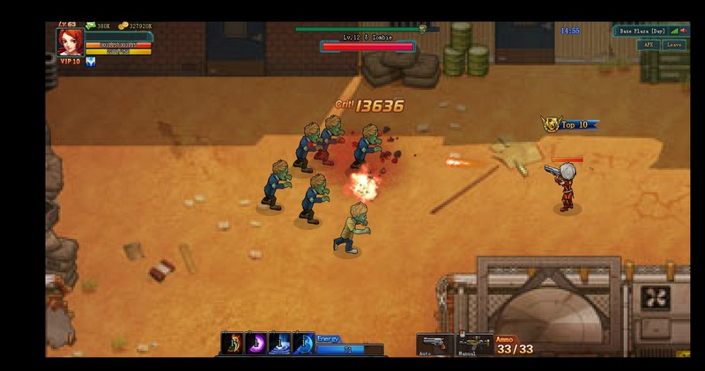  
  
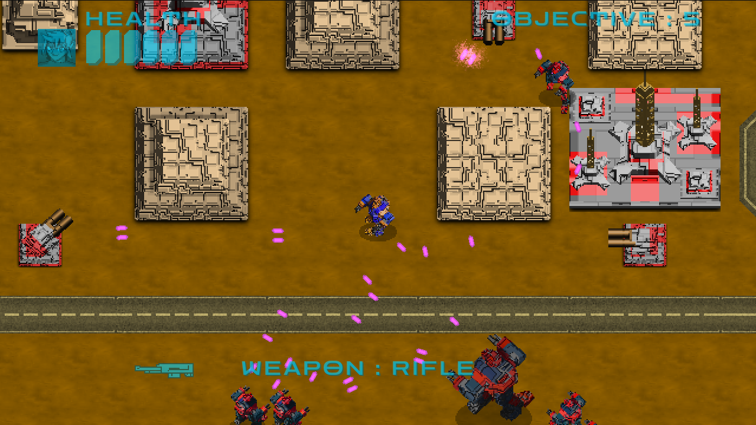

These games all utilise 2D top-down shooter gameplay in order to create challenging, addictive and endlessly replayable gameplay loops. We seek to create a similar gameplay experience in our game: *Winds of Death*. In our own game, the protagonists progress through levels by shooting as many zombies as possible while dodging their attacks. The two players must rely primarily on reaction times and intuition to survive. Similar to the games we were inspired by the players will be able to get weapon upgrades and increase their score by killing enemies.

Characters

In this game. Our characters Hannibal Lector and Norman Bates are survivors in a world where a zombie apocalypse has recently set in. Starting out in the city of New Glasburgh, they must fight their way through various locations including a forest and a river in order to find a boat and escape the mainland. Unfortunately, they’re vastly outnumbered by the zombies so they’ll need to scrounge up whatever firepower they can to succeed on their journey.

## Plot

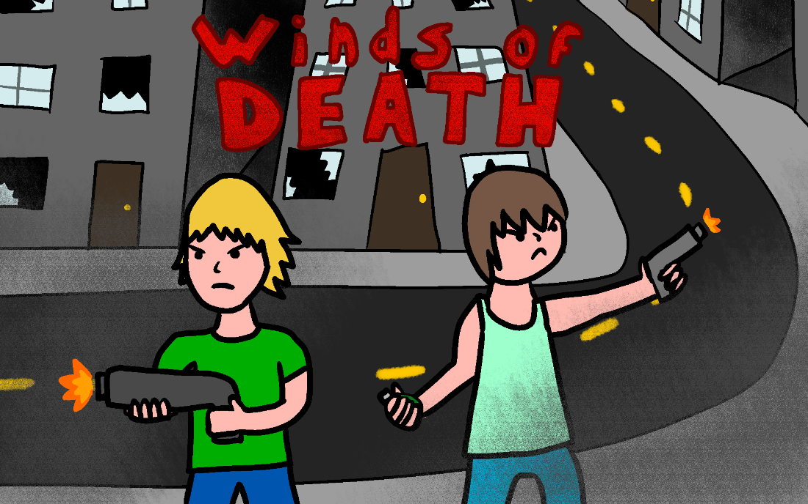

In Winds of Death, you and your co-op partner play as a pair of survivors in a world where a zombie apocalypse has recently set in. Starting out in the city of New Glasburgh, they must fight their way through various locations including a forest and a river in order to find a boat and escape the mainland. Unfortunately, they’re vastly outnumbered by the zombies so they’ll need to scrounge up whatever firepower they can to succeed on their journey

## Gameplay

The core gameplay loop revolves around shooting mechanics working in conjunction with a scoring system. The player will need to kill many zombies to progress to the next level, the final of which will be much larger and full of enemies thus serving as a test of the players skills. Since the game will be a 2-player co-operative experience, both will have their own scoreboard. This will serve to encourage competitive play and increase replayability.

Both players will start each level with a pistol but will be able to pick up new weapons such as shotguns and assault rifles as they progress. Each new weapon will be available on the ground as a pick-up object and will have a different fire mode and rate of fire, providing unique advantages and disadvantages to each. This will also help enhance the competitive nature of the game as there will be a limited number of pick-ups, meaning that the player to reach it first will gain an advantage. There will also be grenades as one-use throwable items.

In the game, the zombies will come in a few different varieties. These will include fast, slow, and regular zombies, each having several hit points inversely proportional to their speed. Each enemy in a particular level will spawn semi-randomly, having a set point to appear from with slight randomness applied to positioning when spawned. Enemy type will be randomised too in later levels to keep the players alert and ready for unexpected challenges.

Game Interface Design

The user interface of our game will be in keeping with the theme of our game, making use of gritty visual elements and blood motifs throughout. The main menu will consist of a button to begin the game and another to view the game credits. The design of the main menu will inform the player of the type of environments they can expect to see in the game's levels.

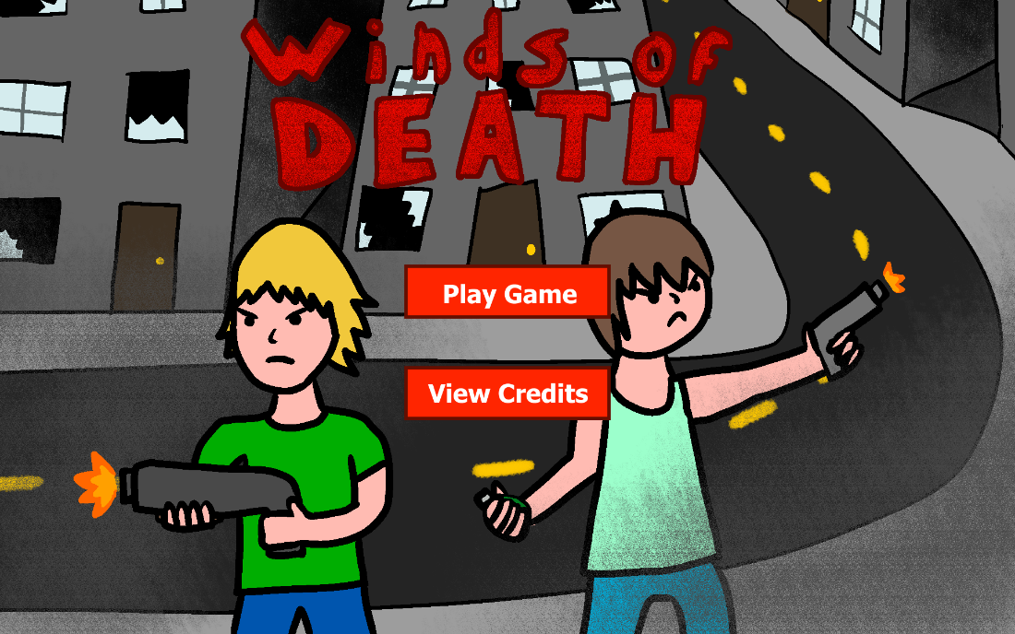

The in-game UI will be as streamlined as possible, only showing information the player needs to know. These elements will include player health bars, score counters, number of lives, current weapon indicators and current objectives. Elements unique to the first and second player (health, score, weapon) will be grouped in the top left and right corners of the screen respectively. Each visual element will adhere to the game’s apocalyptic motif.

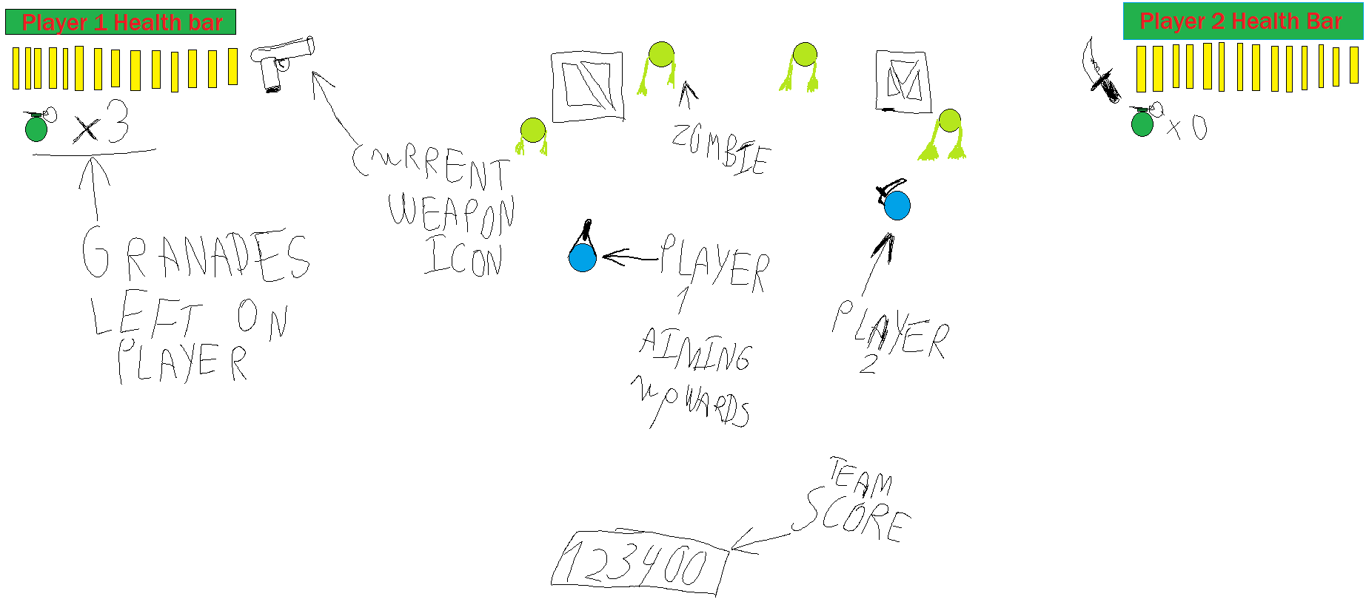

## Game Environment/Level Design

Winds of Death will feature several unique environments across its multiple levels. Each of these areas will offer different challenges through their layout and enemy distribution. Firstly, there’s the city area which serves as the introductory level in the game. The level will feature long straight streets with buildings and occasional alleys for shortcuts and enemy spawns. Cover will be available in the form of overturned cars and barricades from before the city was overrun. The enemy distribution of this level will mostly be medium-sized groups of slow zombies so as not to immediately overwhelm players.

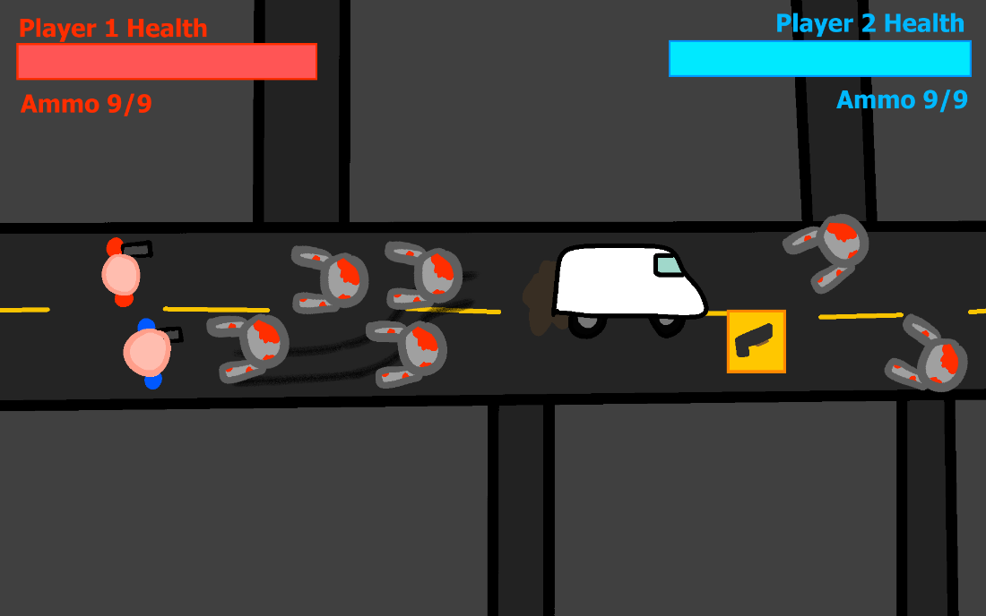

The second level will be an open field with a few trees here and there. This will serve as the introduction of faster zombies with the more open space – compared to the city – giving the player more time to react to this new enemy type. Fallen trees will also be placed sporadically throughout the level to serve as cover for players. There will also be barbed wire fences which serve as both cover and a hazard that will deal damage to anything it touches. Players will have less trouble with this level once they realise that they can lure zombies into the hazards, allowing for more creative kills and conserving ammo in the process.

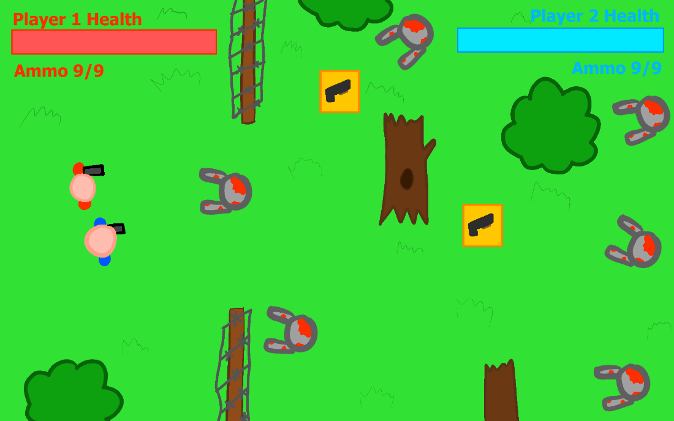

The third level will take place along the banks of a river, starting with either player stuck on either side. They will be required to fight their way along the river separately for a short while before reuniting at a dock and heading to a boat, this being their final objective. The main challenge of this level will be the initial separation along with the lack of cover.

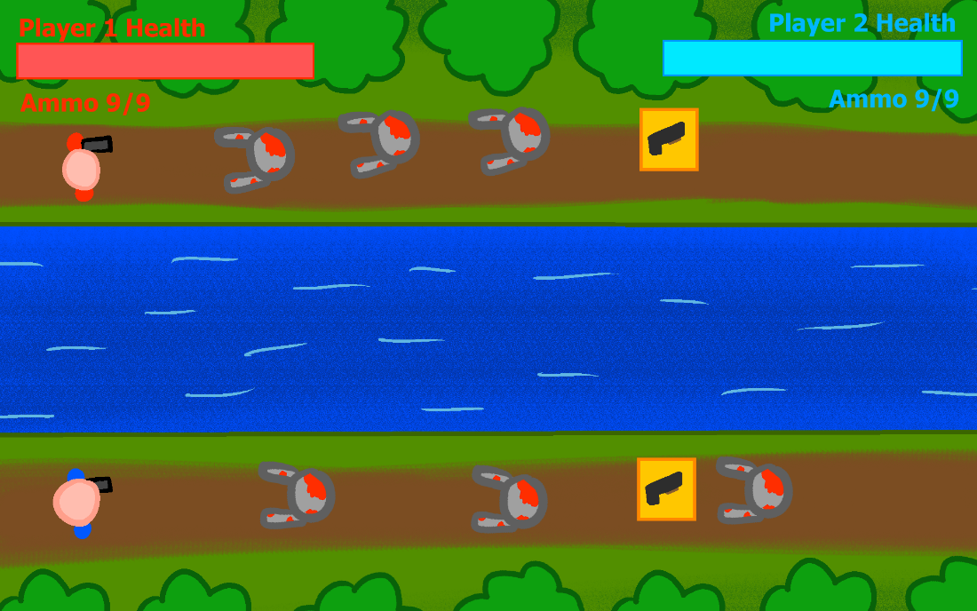

We believe that these levels will each provide their own unique challenges with their unique layouts and characteristics. That said, we do aim to add more levels in future developments as there are still plenty of possibilities left to explore.

# Game Implementation

## Game Features and Future Development Plans

Winds of Death will use the Standard control scheme for a 2D top-down shooter. These controls will include moving with the W, A, S, D keys for Player 1 and using the Arrow keys for Player 2. Other games might use the mouse to assist with aiming but considering our choice to use local co-op, it is best to keep the aim direction to the movement keys. To shoot, the player presses either Space or the Right arow key. We aim to make the gameplay revolve around a competitive scoring system to encourage playing more aggressively, incentivising both players to outperform their partner.

In the future versions of the game, we would like to add the following:

Attacking abilities such as increasing and upgrading the damage that the players weapons cause and increasing and decreasing the firing rate of their weapons. In addition to implementing a weapon pickup system.

Defensive abilities such as upgrading the resistance of player shields and implementing a health pickup system.

Future additions may include the addition of more game levels. There would also be a choice in the options scene for setting the level of difficulty for the game.

### Gameplay & Player Mechanics

The central mechanic of the game will be its shooting mechanic. The player will be able to enhance their characters’ shooting capabilities by collecting pickups for different weapons such as a shotgun or assault rifle, with their starter weapons being pistols. As an extension of the shooting mechanic, one-use grenade pickups will also be available to use. These will be a useful tool for players to clear space in a tense situation where perhaps they are surrounded by too many enemies, unable to shoot enough to make an opening in time to escape. To accentuate their importance as an emergency measure, players will only be able to carry up to 3 grenades at a time. When the player shoots a zombie, they get ten points added onto their score. Stronger guns will have a 2x multiplier while grenade kills give 3 times as many points per kill.

### Pseudocode

**Grenade function**

Key pressed “Q”

{

If (grenades > 0)

{

grenades -= 1

create grenade(at player position, using player rotation)

}

Else

{

print(“No grenades left!”)

}

}

**Player Code**

Switch (key pressed)

{

W pressed:

Move player up

A pressed:

Move player left

D pressed:

Move player right

S pressed:

Move player down

Q pressed:

Throw grenade

E pressed:

Shoot gun

}

Design Pattern

For our game’s development we hope to utilise the Singleton design pattern. We decided that this would be an effective way to approach development as it encompasses using a central class for any particular element that can be accessed globally as it only one instance is able to be instantiated. This would be useful as it would simplify creation of characters in our game and avoid unnecessary confusion in the process.

# Project Management

We decided to choose the Agile development methodology for the web games development two project. This enabled us to use more of a flexible creation process, as it allowed us to use more a frequent iteration of the design and development procedure. Therefore, this mean that the project design and models were developed together, with frequent meetings throughout we established timelines and specifications for our project aspirations.

This meant that as team members we all had to communicate together effectively and efficiently throughout the project development. To help us communicate with one and another we used Microsoft Teams and Discord to allow us to voice chat, text messaging and screen share for the purposefulness of development and implementation meetings.

We will be utilising Microsoft OneDrive as the repository for this project to manage and view game files, developer contributions and production history. The Microsoft OneDrive page is linked here: <https://bit.ly/3EKy8bp>.

In addition, we have also made a project plan and a Gantt chart that we used to set milestones, dependencies, assign issues, risks, and tasks for the project requirements. It has enabled us as a team to better understand our working responsibilities and how our efforts have an impact on the overall project. The overall project plan, Gantt chart and UML diagram is included below on the next page:

## Gannt chart as of 15th September 2021 - Start of project

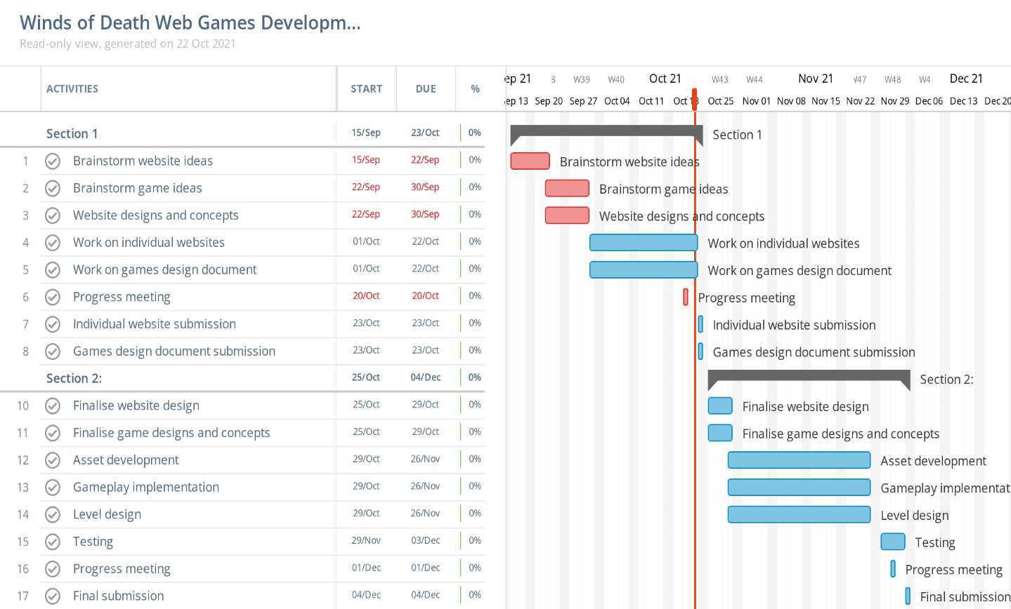

## Gannt chart as of 23rd October 2021 - Halfway point of project

## Gannt chart as of 11th December 2021 – Finishing point of project

## UML Diagram

Below is the UML diagram for our game. It includes the classes for the zombie, player and encounter classes. In addition, it also includes the integers, strings, booleans and variables that we will using in our code.

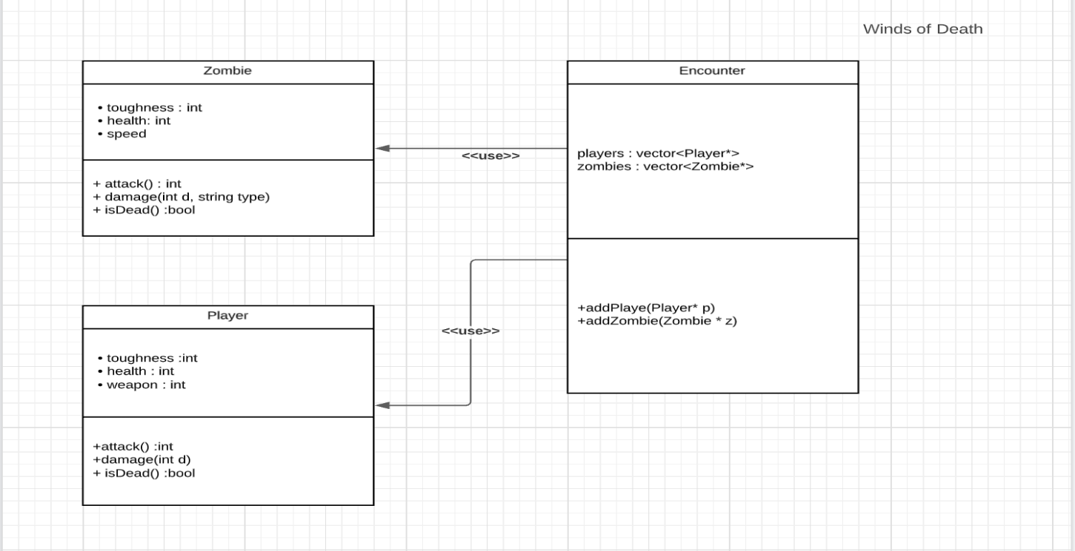

# Roles and responsibilities

## Fraser McAulay B00371477

Roles include:

* Level Design
* Environment Art
* Enemy Character Design
* Enemy Character Implementation
* Documentation
* Player Character Implementation
* Player Character Design
* Audio Development
* Concept Art Development
* Story Design
* Character Voices

## Mohammed Latif B00333837

Roles include:

* Level Design
* Environment Art
* Enemy Character Design
* Enemy Character Implementation
* Documentation
* Player Character Implementation
* Player Character Design
* Audio Development
* Concept Art Development
* Story Design
* Character Voice

## Mihai Maftei B00359190

Roles include:

* Level Design
* Environment Art
* Enemy Character Design
* Enemy Character Implementation
* Documentation
* Player Character Implementation
* Player Character Design
* Audio Development
* Concept Art Development
* Story Design
* Character Voices

Aleksandar Marinov B00351200

Roles include:

* Level Design
* Environment Art
* Enemy Character Design
* Enemy Character Implementation
* Documentation
* Player Character Implementation
* Player Character Design
* Audio Development
* Concept Art Development
* Story Design
* Character Voices

## Software Development Lifecycle Methodologies

Throughout the course of this project, we will be adhering to the Agile development methodology. We chose this one as it allows us to rapidly iterate on our design and make changes to the project spec to fit our evolving vision. We will be making use of Scrum, meaning that we will be doing daily iterations on the project, reflecting on those iterations, and then going forward to iterate once more with hurdles in mind. In the same vein, we will hold regular sprint meetings to discuss the state of the project, what we intend to work on next and any difficulties we might encounter in doing so. We considered other development methodologies but settled on agile as it gave us the most freedom. For example, the Waterfall methodology seemed promising, but it requires that each phase be fully complete before we move onto the next with no possibility of going back if we needed to. Agile suited our needs better as Waterfall was not conducive to the fast and responsive style of development we were aiming for.

# Schedule

## Object 1

### Player Characters – Hannibal Lector and Norman Bates

**Time Scale:**

1 to 3 weeks

• Brainstorming for character ideas, considering character movement system and commence

into implementing the character sprites, mesh and coding.

• Setting up the player character system for moving up, down, left and right. Along the X Axis

and Y Axis

• Finalising character movement system in addition to testing blueprints and code.

## Object 2

### Player Gun

**Time Scale:**

**1 to 3 weeks**

• Brainstorming for character weapons system, considering weapon types and commence

into implementing blueprints and coding

• Setting up the weapon system in conjunction with the player movement system

• Finalising the weapon system in addition to testing blueprints and code.

## Object 3

### Bullet Projectiles

**Time Scale:**

**1 to 3 weeks**

• Brainstorming ideas for bullet projectiles, considering various projectiles to apply and

commence into implementing blueprints and coding

• Setting up the projectile firing system in conjunction with the player gun and player

movement system

• Finalising the projectile firing system in addition to testing blueprints and code.

## Object 4

### Player Map – City area, Open fields, and Banks of a River

**Time Scale:**

**1 to 3 weeks**

• Brain storming ideas for a player map system, considering map variants and commence into

implementing a blueprints and coding.

• Setting up the player map in conjunction with the player movement system

• Finalising the player map system, in addition to testing blueprints and code.

## Object 5

### Player Enemy – Zombies

**Time Scale:**

**1 to 3 weeks**

• Brainstorming for character ideas, considering character movement system and commence

into implementing the character sprites, mesh, and coding.

• Setting up the player character system for moving up, down, left and right. Along the X Axis

and Y Axis

• Finalising character movement system in addition to testing blueprints and code.

# Code examples

The following code below shows we set the texture to the explosion image, then played the animation back. In addition, we also added explosion sounds within an array to the texture for the effect of blowing up our enemies.

The following code shows our player controls and how the play sprite moves up, down, left and right throughout the X axis and Y axis. In addition, our onDestroy is called to go to the game over scene when our player has dead after taking damage from our enemies and projectiles.

The following code below shows our GunShip class. This class loads our enemy and gunship sprites and their movements. In addition, it shows where we set the texture to the explosion image, then played the animation back. In addition, we also added explosion sounds within an array to the texture for the effect of our enemies firing back at our player and blowing up our player.

GitHub Link

We will be utilising Microsoft OneDrive to manage the team’s version control and code sharing. The Microsoft OneDrive page is linked here: <https://bit.ly/3EKy8bp>.

## Version 1

In the future versions of the game, we would like to add the following:

Attacking abilities such as increasing and upgrading the damage that the players weapons cause and increasing or decreasing the firing rate of their weapons. In addition to implementing a weapon pickup system.

Defensive abilities such as upgrading the resistance of player shields and implementing a health pickup system.

Future additions may include the addition of more game levels. There would also be a choice in the options scene for setting the level of difficulty for the game.

References

*Agile Game Development – A Quick Overview - Marionette Studio (2016)*

[*https://marionettestudio.com/agile-game-development-quick-overview/*](https://marionettestudio.com/agile-game-development-quick-overview/)

*Game-Scrum: An Approach to Agile Game Development - Andre Godoy, Ellen F. Barbosa (2010)*

[*http://sbgames.org/papers/sbgames10/computing/short/Computing_short19.pdf*](http://sbgames.org/papers/sbgames10/computing/short/Computing_short19.pdf)

*Java Singleton Design Pattern Best Practices with Examples (2013)*

[*https://www.journaldev.com/1377/java-singleton-design-pattern-best-practices-examples*](https://www.journaldev.com/1377/java-singleton-design-pattern-best-practices-examples)

*Top 4 software development methodologies – Synopsys (2017)*

[*https://www.synopsys.com/blogs/software-security/top-4-software-development-methodologies/*](https://www.synopsys.com/blogs/software-security/top-4-software-development-methodologies/)